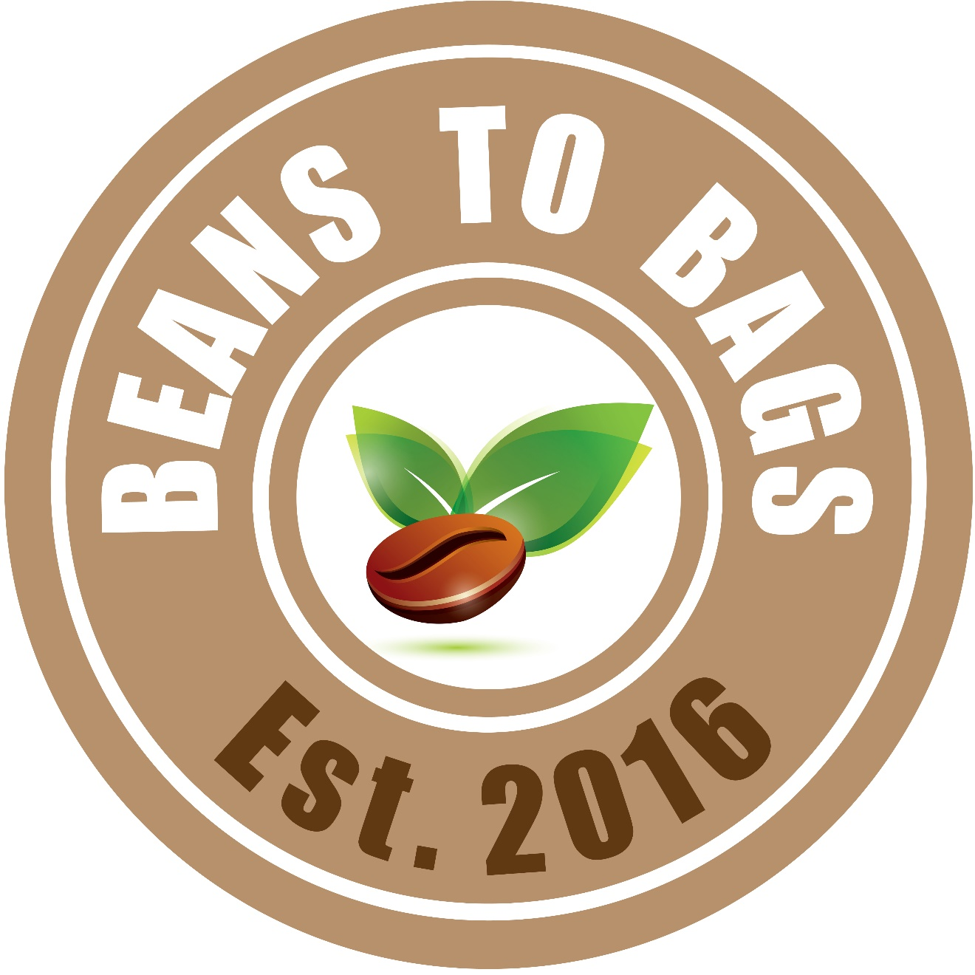

BEANS TO BAGS – 2020 EARN YOUR WAY
ORDER, PAYMENT, AND DELIVERY DATES

ORDER/PAYMENT BY DATES | DELIVERY DATES (MONDAYS)
January 30th | February 3rd
Mid-Winter Break
February 20th | February 24th
February 28th | March 2nd
March 12th | March 16th
March 26th | March 30th
Spring Break
April 16th | April 20th
April 30th | May 4th
May 14th | May 18th

- Go online (https://www.signupgenius.com/go/60b0949afa62aaaf85-washington) to place your order based on the above dates.
- Submit money to the AMS office in a sealed envelope. Write your child’s first and last name and Beans to Bags on the envelope.
- Remind your child to pick up the orders during lunch on the following Monday.

Please contact Bonnie Kakuda with questions at info@beanstobags.org.

